COMP 2920 : Software Architecture & Design
Class Activity#3
Date : September 27, 2017 Due time : end of the day today
Weight : 2%

This assignment can be done in the group of two students.
Let us think of a college course registration system. For this case study, you need to answer the following questions:

For the system selected:
- Refine the scope of the system. Describe in 2-3 paragraphs the scale of the organization sponsoring the system, and their target audience (customer base)
- Identify the actors involved in use of the system. Remember to include appropriate management and system support personnel, and external systems if applicable.
- Identify about 3-4 significant (i.e. non-trivial) use cases for the system. Remember that each type of actor should have some use cases, and include support, management, and administrative functions, not just end user functions.
- Determine the primary actor for each use case.
- Prepare a use case diagram for your system.
- Pick one use case, and provide detailed documentation of that use case in the form of use case scenario table
- Pick two other use cases, and provide casual documentation of those use cases.

In summary, from this assignment I expect to see:
- From part a), 2-3 paragraphs of text.
- From part e), the use case diagram.
- From part f), one detailed use case description.
- From part g), two casual use case descriptions.

College Course Registration:

The college course registration system would have multiple types of users such as STUDENTS, PROFESSORS, REGISTRATION OFFICIALS and ADMINS.

The System should be able to accommodate several users and should be able to properly refine and filter content to be displayed to each user according to his/her status. Each user should be able to login to the system with their unique password and usernames.

For students: A student should be able to login to the system with their student ID and password and browse the list of courses that are being offered in the coming semester. The student should also be able to view their own schedule and also the times of the classes, pre-requisites of the course and a description of the course module.

For professors: The professors should be able to view courses that have been assigned to them. And also check their schedule of classes and office hours. The professors would also be able to alter any course details of courses that have been assigned.

Registration Officials: These would be responsible for updating the list of courses offered and also alter the classrooms, schedules and register and unregister students from classes. Also, these would be able to check student details to make sure that they have been permitted and are eligible to register in courses.

Admin: These would be able to perform backups, updates and also check for any errors in schedules and correct necessary mistakes.

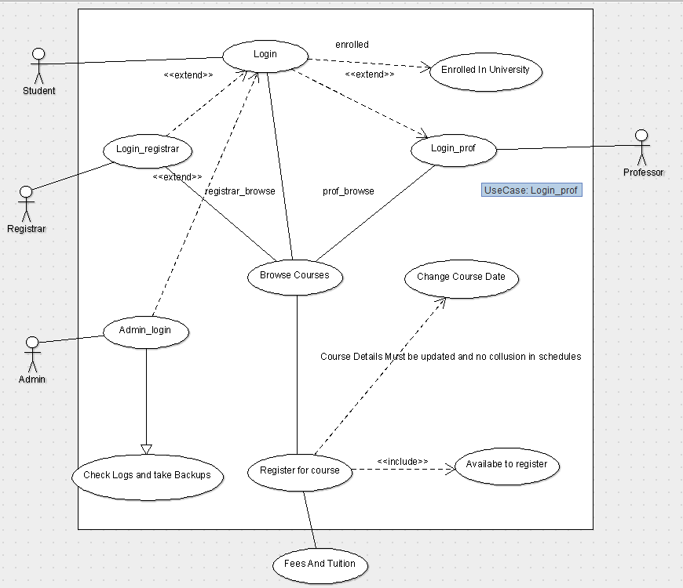

Detailed Use case description
Use case number and name | STUDENT REGISTRATION ID: 1
Objective | Student can register for a course
Primary Actor | Student
Secondary Actor(s) | Registration Services, Professor, Finance Department
Trigger | Student Clicks on Register on course details page
Precondition | Student is enrolled in University and has login authentications
Post condition | User is registered in course
Main Success Scenario | - User is registered in course  - Success Message is shown  - Student schedule is updated
Performance time
Frequency
Normal flow | - The Use Case starts when the user logins to starts the application.  - The system will display the student details page  - The user performs a search for the course to find.  - The course list is displayed with all sections of the course.  - Student can view the course details and pre-requisites and also view the timings of the classes.  - The system will display the main screen.  - Student can select a button to register into the course  - If no conflict with user schedule and also student is eligible to register and course has enough seats available, student can click on register button to register in the course.  - User can view his updated schedule and check
Alternate flow | - Case 1: User is not eligible to register for course because he has not been permitted  - User is able to search for course and check schedule for all courses.  - User is unable to see the “Register” button  - User is shown an error message stating that he has to first get permission from professors

Use case number and name | User can search for a course ID 001
Objective | User can perform searches based on course name and ID
Primary Actor | Student
Main Success Scenario | - Course list of courses meeting the search criteria are displayed in a list with links to details of each
Flow | - Student logs in to the system  - User navigates to search screen  - User enters valid search criteria

Use case number and name | Registration Office can alter courses
Objective | Registration Office should be able to add or remove courses to be available for registration
Primary Actor | Registration Office
Main Success Scenario | - Courses list is updated and students see the updated list  - Schedule for all courses is updated also for registered students and unregistered
Flow | - Registrar logs in to the system.  - Registrar can search for a course to alter  - Opens course to alter  - Alters details and saves the changes  - Course details are updated for all

JAGJIT SINGH BILKHU – T00533766

